Adaptive Equalization Using the LMS Algorithm
- An adaptive equalizer is an equalizer that automatically adapts to time-varying properties of the communication channel. It is frequently used with coherent modulations such as phase shift keying, mitigating the effects of multipath propagation and Doppler spreading.

CODE:
% Adaptive equalization
% Simulate some (useful) signal to be transmitted

>> ni=6000; % length of input
a=(randn(1,ni)>0)*4-1; % Random bipolar
>> nn=length(a);

% Channel Model
%w=2.89;

w=3;
>> h = [0,0.5*(1 + cos(2*(pi/w)*(-1:1)))];
>> n = length(h);

%ah=conv(h,a);

>> ah=filter(h,1,a);
mu=0.012;
>> plot(a,'.')
>> plot(ah,'.')
>> NN=11; %adaptive filter length
>> w=zeros(1,NN); %initial adaptive filter coefficient
v=sqrt(0.001)*randn(1,ni); %Gaussian noise with variance 0.001;
u=ah(1:ni)+v;
delay=NN-1;
px=zeros(1,NN);

%for 1=NN+1:ni
%y(i)=w’*u((i-NN):(i-1));
%e(i)=a(i-delay)-y(i);
%w=w+mu*e(i)*u((i-NN):(i-1));
%J(i)=e(i)^2;
%end

E=[];aa=[zeros(1,delay) a(1:ni-delay)];
>> for i=1:ni;
px=[u(i) px(1:length(px)-1)];
y(i)=w*px';
e=aa(i)-y(i);
w=w+mu*e*px;
end
pause
subplot(221), plot(a,'.'), title('original signal to be transmitted')
subplot(222), plot(ah,'.'), title('convolved (distorted)signal h*a')
subplot(223), plot(u,'.'), title('signal after addition of noise')
subplot(224),plot(y, '.'),title('Output signal')
for i=1:length(y);
if y(i)>=0.5,S(i)=1;
else S(i)=-1;
end
end
>> tr=a(1:length(a)-(NN-1));
rx=S(NN:length(S));
k=0;
for j=1:length(tr);
if tr(j)~=rx(j), k=k+1;
end
end
BER=k./(length(rx));
pause
subplot(221), stem((h)), title('channel input response h(n)')
subplot(222), stem(ah,'.'), title('convolved (distorted)signal h*a')

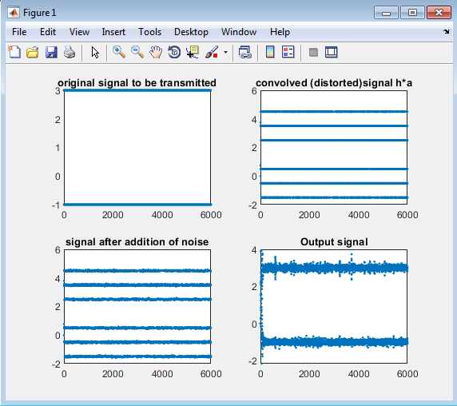

CONCLUSION:
By performing this code we learnt the equalizing properties of an adaptive equalizer. It automatically adapts the time varying properties of a communicating channel. We can get the value of output as we want by changing the value of “mu”.

